**Market Basket Analysis**

Imagine 10000 receipts sitting on your table. Each receipt represents a transaction with items that were purchased. The receipt is a representation of stuff that went into a customer’s basket – and therefore ‘**Market Basket Analysis**’. That is exactly what the Groceries Data Set contains: a collection of receipts with each line representing 1 receipt and the items purchased. Each line is called a transaction and each column in a row represents an item.

Please download the dataset and perform Market Basket analysis and look at association rules. This will help you understand what goods can be bundled and what types of promotions or discounts can be offered on the products either online or at the retail store!

Dataset: [groceries-1.csv](https://olympus.greatlearning.in/courses/4750/files/466542/download?verifier=CN1GyBclSlVOfJexub6y0VLSDF2aFZk6TxnZqraQ&wrap=1)

**Group Members**

1. Aditya Godse
2. Akshay Surve
3. Amay Saxena

**Answer**

**CSV Reader**

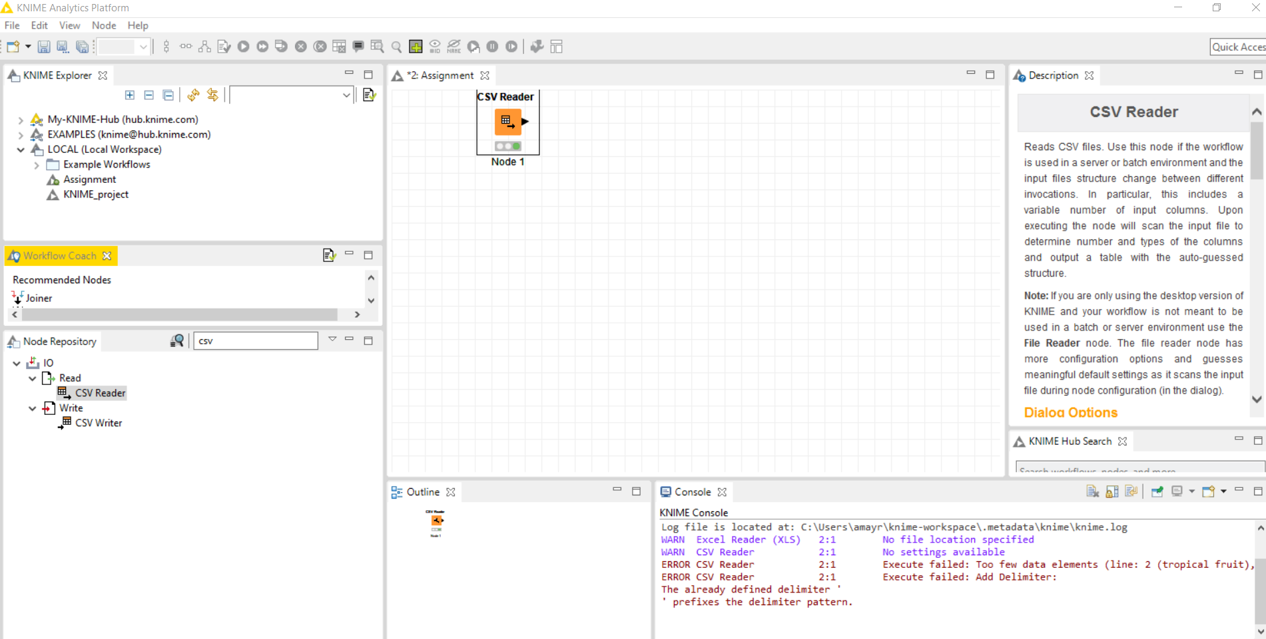

**CSV Output**

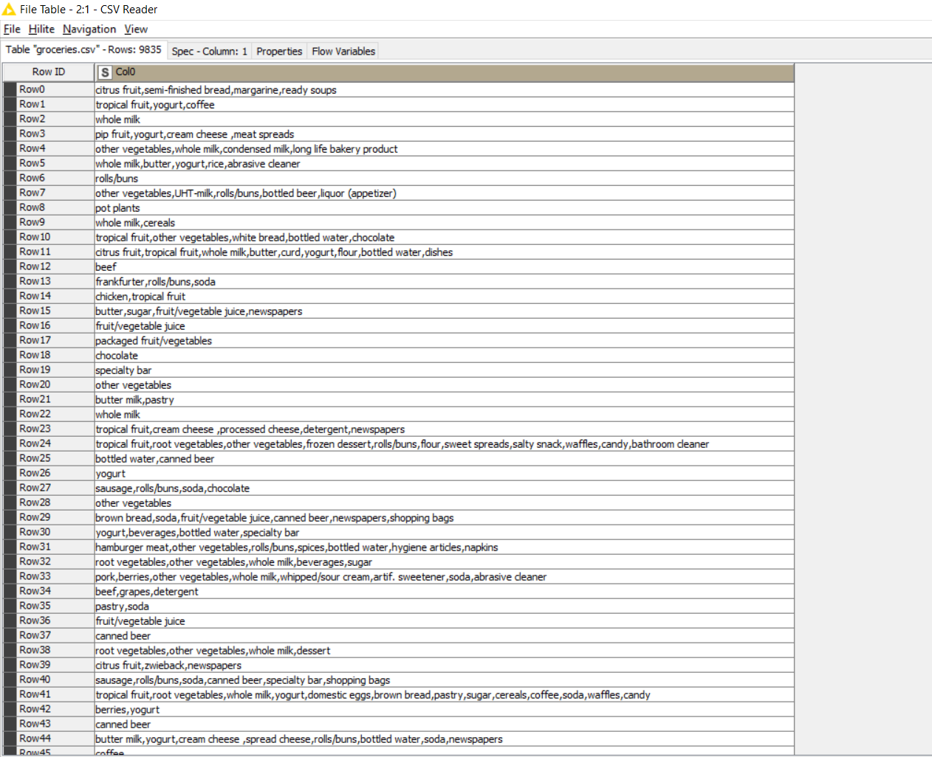

This was the output after reading the data from CSV

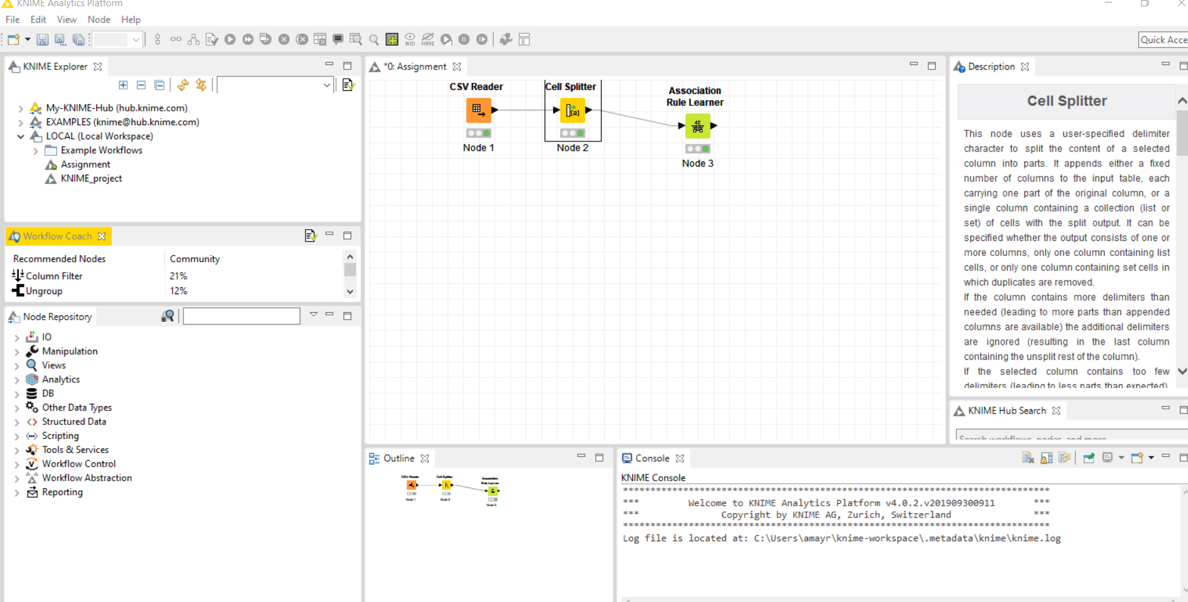

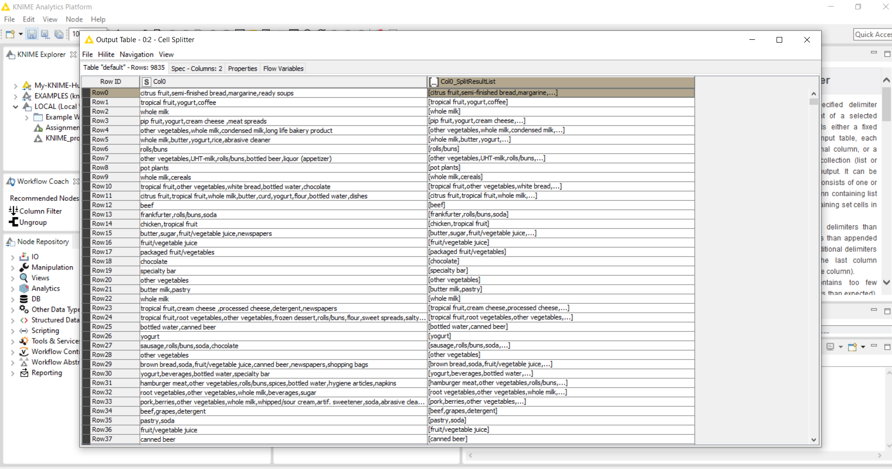

I can see data can be grouped into a list and then list can be used to achieve association rules further.

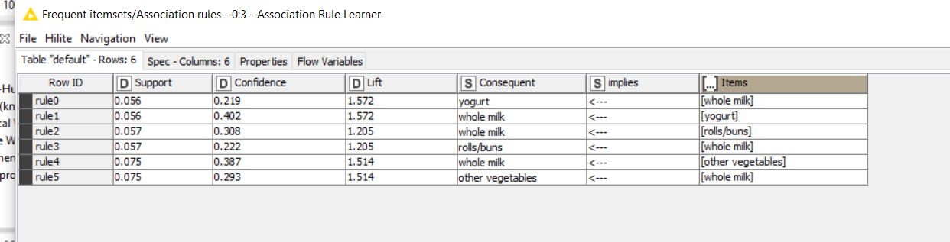

So, we have 5 association rules for products bought through thousand receipts, based on different confidence and lift.

As, per Lift, with 1.572 as lift, we can see yogurt and whole milk can be clubbed in same basket and so can be recommended, though confidence (.402) is more in case of buying yogurt and then by buying whole milk.

Again, when we see buying vegetables, then whole milk seems to be good recommendation with 1.514 as lift and greater confidence of .387

With 1.205 as lift, buying whole and rolls/burns looks little less profitable association or recommendation.